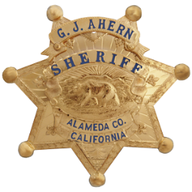 County of Alameda

INITIAL ADMINISTRATION REVIEW

Parking Violation Level 1

**Level I Appeal:** You may file a request for a Level I Appeal; however, this must be done within 21 calendar days from the date of the issued citation. Level I Appeals must be in writing and completed correctly. You will receive a response by mail within 4-6 weeks of filing this form.

Please mail completed form to: **Alameda County Sheriff’s Office 15001 Foothill Blvd, San Leandro 94578**

**If your citation is over the 21 calendar day time frame, please mail your payment to:

**Alameda County Parking Enforcement Center P.O. Box 3214 Milwaukee, WI 53201—866-219-8701**

**Level II Appeal:** After a Level I Appeal has been completed and a finding made, if you are not in agreement with the judgement, you may file for a Level II Appeal hearing. When you receive the judgement from Level I in the mail, you must pay the amount owed for the citation and mail it to the appropriate address, as well as marking a box at the bottom, “Hearing in Person” or “Hearing in Writing” to continue the review process.

**Parking Appeal Court:** Occur only after Level I and II Appeals are completed. All court judgements are final.

*Exhibits will not be returned.

|  |  |
| --- | --- |
| Name | Citation Number |
| Address | Violation Number(s) |
| City, State, Zip | Date & Time Issued |
| Home Phone Work Phone | Vehicle License Number |
| Violation Location | |
| Statements of facts (If more room is needed, use the back of this paper) | |
|  | |
|  | |
|  | |
|  | |
|  | |
|  | |
|  | |
|  | |
| Signature: | Date: |

Please attach your citation and any additional exhibits which support your request.

**FOR OFFICIAL USE ONLY**

Date Received­­­­­­­­­­­­­­_______________ Reviewed By__________________ Badge Number_________________

Citation (Circle One): Valid­­­­­­­­­­­­­­­­­­ OR Dismissed

Notes: ____________________________